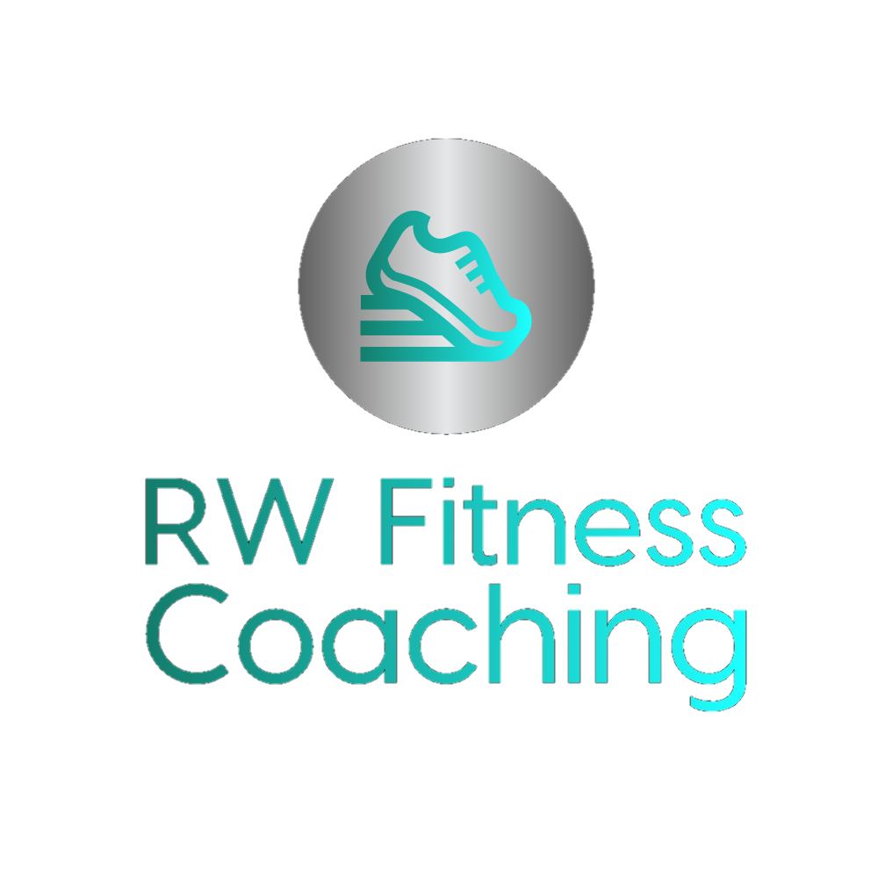

PARTICIPANT DETAILS
INFORMATION AND INFORMED CONSENT

Please read carefully and fill in the following

Name:

Address:

Tel:

Email:

Date of birth:

Emergency contact:

Relationship:

Address:

Tel:

If you are not feeling well because of a temporary illness such as a cold or fever - delay becoming much more active and wait until you feel better.

COVID-19

Please do not attend training if you are showing any signs of Covid-19 or if anyone in your household is showing signs of Covid-19.
Please contact your coach immediately if at any time between training sessions you test positive for or have been in contact with anyone who has tested positive for Covid-19.
Please bring your own water and please feel free to bring your own mat.

All equipment and mats will be thoroughly cleaned with anti-viral and anti-bacterial cleaner before and after each session.

If you are or may be pregnant - talk to a doctor before you start becoming more active.

If you have given birth in the past year please inform your coach.

PLEASE NOTE: KETTLEBELL CLASSES ARE UNSUITABLE FOR THOSE WHO ARE UNDER THE AGE OF 16 AND THOSE WHO ARE PREGNANT.

If your health changes so that you answer YES to any of the questions below, tell your coach and ask if you should change your physical activity pl

Exercise programmes are designed to improve cardiovascular (heart and lungs) fitness, muscle strength and endurance as well as flexibility. Programmes may include activities such as running, stretching, lifting weights and use of other equipment. Each part of the programme will be fully explained to you but please ask questions if you are unclear about anything. Please notify your coach if you feel you should not do a particular exercise for any reason.

This form should be signed and passed to your coach prior to taking part in an exercise programme.

Exercise programmes contain certain risks such as muscle strains, joint sprains, aches, pains and general discomfort from parts of the body not used to exercise. The programme is designed to minimise these risks; however, if you feel unwell you must stop and inform your coach immediately

To avoid injury or breakage, jewellery and watches should be removed before commencement of physical activity. This is particularly advisable during Kettlebell classes where the kettlebell may connect with the wrist.
If your health changes so that you answer YES to any of the questions below, tell your coach and ask if you should change your physical activity plan. If you should have a break from exercising with RW Fitness Coaching for a period of 3 months or more (for whatever reason) you may be asked to fill out another PAR-Q and informed consent form.

You should be in good physical condition and able to participate in exercise. If you engage in this exercises or exercises programme, you agree that you do so at your own risk, are voluntarily participating in these activities, and assume all risks of injury to yourself.

REMOTE TRAINING & CLIENTS WHO USE
THE RW FITNESS COACHING/ EVERFIT APP

By using the app you agree to follow all the exercise instructions, training points and all safety points.

You agree to -

Wear appropriate exercise clothing and footwear at all times, e.g. trainers/ running shoes.

Keep yourself hydrated by always having water available to you while exercising.

Stop immediately If you feel any pain or discomfort. If you are unable to execute any of the exercises in the correct manner for any reason you may move on to the next part of the programme.

Make contact with RW Fitness Coaching if there are any instructions for any exercises that are unclear or there are any points that need clarifying.

I ………………………………………………………………………..confirm that I have read and understood the above and that any questions I had were answered to my full satisfaction.

Name

Signature

For participants under the age of 16
Name of parent/ guardian

Signature of parent/ guardian

PRIVACY AGREEMENT

RW Fitness Coaching is registered with The Information Commissioner's Office.

We are required to inform you of the personal data we hold about you and how we use that personal data.

RW Fitness Coaching process personal information in order to fulfil the contract of provision of the Fitness Coaching services you are engaging in. Your health data is necessary for legal purposes and to ensure that we are appropriately qualified to help you. We will ensure your data is appropriately protected at all times. All paper files are kept in a locked container and all computer files are password protected, in line with the Data Protection Act 2018.

We are legally required to keep your data on file for 7 years after you have finished using our services, in accordance with HMRC requirements and to protect against possible litigation.

You may request to see the information we hold and you have the right to request that it be corrected or deleted at any time.

You have the right to lodge a complaint with the Information Commissioner’s Office (ICO) should you believe that we are not processing your information in accordance with the law or if you believe your request has not been dealt with appropriately.

How we share your information

We may use and share your information with third parties to enable us to comply with any legal or regulatory requirements; to protect or enforce our rights or the rights of any third party such as by analysing activity on our network to help block unauthorised or illegitimate content, publication of, or access to it; and for the purpose of safeguarding an individual’s vital interests, national security, responding to statutory obligations or requests from the courts and enforcement authorities.

We use the following platforms and software to deliver our services, and details of how your data are shared and protected are provided below.

Personal training Clients will be given the option to access Session X. Session X is an additional fitness platform hosted by Lift The Bar.
If you choose to access Session X any and all information that we are required to share with Lift The Bar will first be approved by you.

Our company is hosted on the Wix.com platform. Wix.com provides us with the online platform that allows us to sell our products and services to you. Your data may be stored through Wix.com’s data storage, databases and the general Wix.com applications. They store your data on secure servers behind a firewall. It is possible that your personal data may be stored in the US. Following a recent ruling stating that US cloud servers are incapable of complying with the GDPR, we have to make you aware of the potential risks of your data being processed in the US under less strict privacy laws, and you have to give explicit consent to this occurring.

RW Fitness Coaching does take payments through Wix but you are not required to provide Wix with any payment details, as you are given the option to pay in person. In any case, all direct payment gateways offered by Wix.com and used by our company adhere to the standards set by PCI-DSS as managed by the PCI Security Standards Council, which is a joint effort of brands like Visa, MasterCard, American Express and Discover. PCI-DSS requirements help ensure the secure handling of credit card information by our store and its service providers.

Payments can also be taken through Paypal- for further details please refer to
www.paypal.com/ca/webapps/mpp/ua/privacy-full
to view the Paypal privacy policy.

Clients are given the option to join a Whats App group. For that purpose names and telephone numbers are required by Whats App.
Payments can be taken for online classes by prior arrangement- online payments are optional.

At times we may request Zoom meetings or Goggle meet meetings. Zoom requires that you set up an account with them and provide your email address. If you are unable/ unwilling to access Zoom, telephone appointments can take place instead.
Google meet meetings are set up by us and a link will be emailed to you. You do not need to have a google account to participate in a google meet.

You can view Zoom’s privacy policy at zoom.us/privacy
You can view the Google meet privacy policy at policies.google.com/privacy
Card payments are taken by sum up. Details of their privacy policy can be found at www.sumup.com/en-gb/privacy

We also accept cash, cheques and bank transfers if you would prefer.

Remote training clients will be required to use the RW Fitness Coaching/ Everfit app. Face to face clients will be given the option to use the RW Fitness Coaching/ Everfit app, to aid their fitness journey and to enable/ encourage them to exercise between appointments. You can view Everfit’s privacy policy at everfit.io/privacy/
Everfit may ask you to link up to Google fit: this is entirely optional and if you choose to do so their privacy policy can be viewed at https://developers.google.com

Personal training clients will be encouraged to use the Nutracheck app. Through this you can track your activity and your nutritional intake. This is optional- you can choose to track your progress on paper in a diary format if you prefer, or you can choose to use a different nutrition app.
To view Nutracheck’s privacy policy go to www.nutracheck.co.uk/info/privacy
The Nutracheck app links up to most fitness trackers. You are not required to purchase a fitness tracker to use the app, as your activities can be added manually.

Alternative nutritional apps and any apps that are required with your chosen fitness tracking device are entirely optional, so therefore do not need to be listed in this policy document.

All of the above is stated on the RW Fitness Coaching website, rwfitnesscoaching.co.uk, on the Privacy Policy page.

I …………………………………………………………………………..confirm that I consent to RW Fitness Coaching storing my personal data on hard copy documents and electronic files as described above, and processing it for the purpose of providing me with fitness coaching services.
I understand and accept the risks associated with my data potentially being stored and processed on US cloud based servers.
Videos and images will only be taken and stored by prior agreement.

Signed ……………………………………………..

Date…………………………………..

RW Fitness Coaching may also contact you from time to time to discuss internal changes to fitness coaching programmes, check in with you, and organise appointments and bookings.
RW Fitness Coaching may wish to send you information related to fitness coaching services or related activities.

Please confirm if you are happy to receive these service communications.

Yes/No
If you have any further questions please contact Rosie Webb- rwfitnesscoaching@gmail.com

INFORMED CONSENT

I…………………………………………………………………………………understand that my participation in exercise programmes, classes or events and any other related activity conducted by RW Fitness Coaching, is voluntary and at my own risk.

I am aware that exercise can be physically stressful and, in certain instances can result in injury.

I hereby state that I will inform the trainer of any symptoms (e.g. fatigue, shortness of breath, chest discomfort, any pain/concern for my safety/ benefit) during my participation in exercise.

I understand that I will be given instructions on how to perform the exercises and use the equipment and will ask the trainer questions if I do not understand.

I acknowledge that I have read this document in its entirety and understand the above. I have had the opportunity to ask questions and receive answers.
Programme objectives and procedures

I understand that the purpose of the exercise programme is to provide safe and individualised exercise to improve health and fitness. Exercises may include:

cardiovascular machine activities- treadmill walking or jogging, rowing, upright or recumbent cycling, stair climbing and other such activities in outdoor environments;
resistance training activities using resistance machines, free weights or circuit training to improve muscular strength or endurance;
core and flexibility exercises to improve core stability and movement around the joints and range of motion.

Potential risks

The exercise programme is designed to place a gradually increasing workload on the cardiovascular and muscular systems and thereby improve their function. The reaction of the cardiovascular and muscular system to such exercise cannot always be predicted with complete accuracy. There is a risk of certain changes that might occur during or following the exercise. These changes could relate to blood pressure or heart rate.

Potential benefits

I understand that a programme of regular exercise has been shown to be beneficial. Some of these benefits include-
A decrease in risk of heart disease
A decrease in body fat
Improved blood pressure
Improvement in psychological function
Improvement in aerobic fitness
The training programme has been explained to me and my questions regarding the programme have been answered to my satisfaction. I understand that I am free to withdraw at any time. The information obtained will be treated as private and confidential.

Client Name Trainer Name

Client signature Trainer signature

Date

